Watercolour Seminars Alonnisos
How to reach Alonnisos
You can check on the internet for package holidays to Alonissos. I suggest you choose an accommodation in the Old Village to be close to where the seminar is held.
If you prefer to arrange the trip yourself you have to look for flights to the island of Skiathos.
From Skiathos it takes 1½-3 hours to Alonissos with a hydrofoil or ferry.
If you prefer to fly to either Thessaloniki, Athens or Volos it takes between 3 to 6 hours to reach Alonnisos.
Via Skiathos, Volos and Thessaloniki: Ferry boats or Flying Dolphin or CAT, which are hydrofoils to Alonnisos. See Hellenic Seaways www.hsw.gr or www.openseas.gr for reservation, time schedule and prices.
Via Athens: Flights to Athens and then a bus from the center of Athens to Agios Konstantinos, Volos, Kimi or Mantoudi and from there ferry boat or Flying CAT hydrofoil to Alonnisos. The bus services usually connect with the Flying CAT or ferries. See Hellenic Seaways www.hsw.gr or www.openseas.gr for reservation, time schedule and prices.
UNFORTUNATELY THE SUMMER TIMETABLES ARE OUT LATE SO ITS DIFFICULT TO BOOK EARLY
Accommodation
Either you prefer a package solution or to find an accommodation on your own I recommend an accommodation in the Old Village where the teaching takes place.
Fantasia House: Small pension situated at the central church square of the village. Double room including refrigerator, water-boiler, toilet and bath or studio with a small kitchen. Great view over the village and the sea.
http://alonissos.gr/en/accommodation-in-alonissos/rooms-to-let/fantasia.html.
Chiliadromia: The pension is situated at the central church square of the village. Big studios including kitchen, toilet and bath or double rooms including refrigerator, water-boiler, toilet and bath. Breakfast café. Different views over the landscape and sea.
More information and booking: www.chiliadromia.gr.
Anatoli: The pension is situated at the central church square of the village. Big studios including kitchen, toilet and bath. Breakfast café. Great view over the landscape and sea.
More information and booking: www.anatolistudios.gr

Activities in your free time
Swimming
The nearest beach is just below the village at half an hour’s walking distance. You can also drive down or book a taxi. There are two tavernas on the beach so you can enjoy your meal with a view over the blue Mediterranean, uninhabited rocky islands and the island of Skopelos in the distance.
Hiking
If you are interested in hiking or exploring the island in general you should find my books Alonnisos on Foot and The Alonnisos Guide to be both practical and pleasant to use. You will find them packed with a great variety of information, including directions to many beaches, fishing villages and different places of interest in the countryside.
Excursions
If you stay on after the end of the course it is possible to join the excursion boats in trips to the Marine Park. You will visit some of the uninhabited islands in the protected area, where dolphins often approach the boat. The area is protected to try to save the endangered Mediterranean Monk seal.
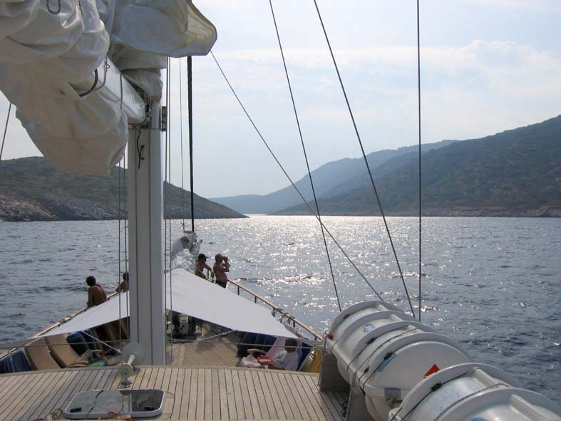

Conditions and return policy
The booking is binding and if you cancel more than 40 days before the start of the course only 50% of the deposit will be returned.
If you cancel less than 40 days prior to the course your payment will be returned only in case of documented illness and minus 50% of the deposit.
About Alonnisos
Alonnisos is a beautiful, green island situated in the northwest of the Aegean Sea, about 40 kilometres from Pelion on the Greek mainland. It belongs to the Northern Sporadic group of islands, which from a geological standpoint are contiguous with the mainland, despite the intervening submerged area. Alonnisos is a roughly oblong island, about 20 km long and between 3 km and 4 km wide. The island has a magnificent and varied natural history which has made a deep impression on generations of visitors.
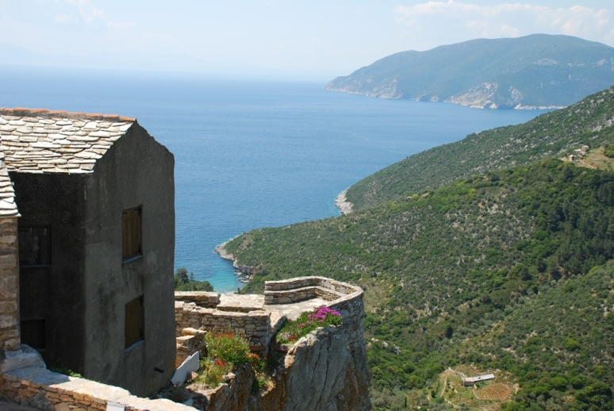 | 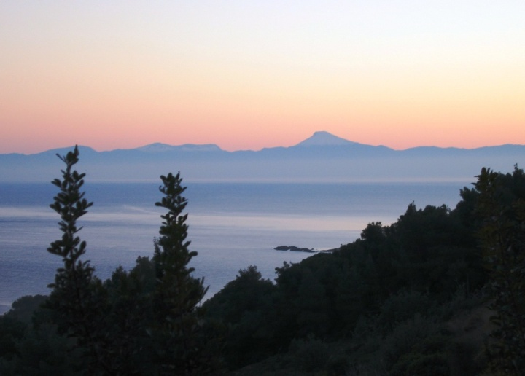
Even as the boat approaches the island, your first impressions are of a landscape rich in contrasts. The western promontory rises precipitously from the sea in rugged cliff formations to a height of 300 metres but soon rolling, green hills emerge from behind the promontory, and a small village appears at their peak. This village, Palia Alonnisos (Old Alonnisos), is the former main settlement of the island.
After another 15 minutes travel along the beautiful pine-clad southeast coast you arrive at the main harbour of the island, Patitiri. The harbour is situated in a small bay with clear turquoise waters, surrounded by steep, ochre-yellow cliffs. The area behind the harbour is densely developed and the built-up area continues into the next bay, Rousoum, and on into the neighbouring fishing village of Votsi.
Apart from these settlements (Palia Alonnisos, Patitiri and Votsi) there are two more villages, both further up the southeast coast. The first is Steni Vala (by road, 10 km from Patitiri), a charming little fishing village and home port for many sailors, as it is the last place to take on provisions before visiting the many uninhabited islands in the area. A little further up the coast is the last small built-up area Kalamakia, which consists of a few houses and a small harbour.
Alonnisos is studded with beaches where you can swim in the crystal clear waters. Each of the beaches is more picturesque than the last, and they are all very different in character.
The colourful landscape, the dramatic cliffs and the wide variety of vegetation on the island make it a magnet for nature-lovers; just to take in the fantastic views, or to smell the aromatic herbs that grow all over the island, are wonderful experiences in themselves.
There are many possibilities for hiking in Alonnisos, as many of the old donkey paths are kept open, and most of the areas of the island are easy to reach, even with peaks of up to 475 metres.
If you want to read more about Alonnisos see The Alonnisos Guide and Alonnisos on Foot

