Chakra Empowerment &

Wake-up your Senses
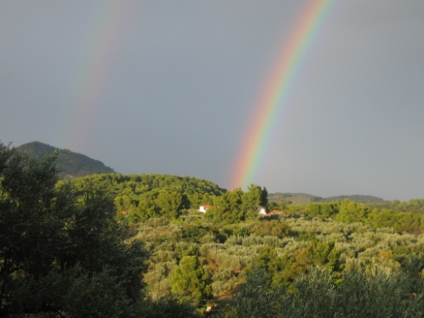 | 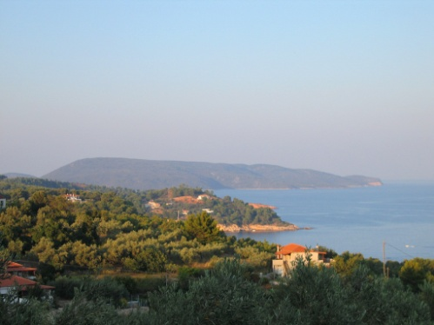 | 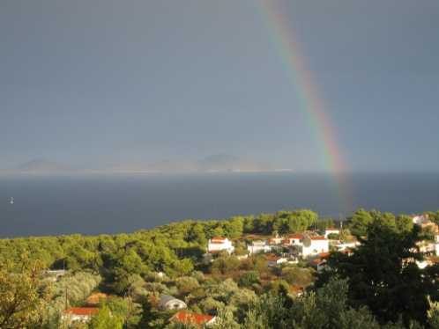
The view from the course centre
Where will the work-shop be held?
The Chakra Empowerment & Wake-up your Senses work-shop will be held in a shady olive grove overlooking the sea and the village of Votsi. You can easily reach the course centre from Votsi, Rousoum or Patitiri along a footpath.
After the morning gym we continue the teaching at the course centre and/or we meet again in the afternoon and are around on the island visiting scented woods, small chapels, a beach, the Old Village and experiencing fantastic views.
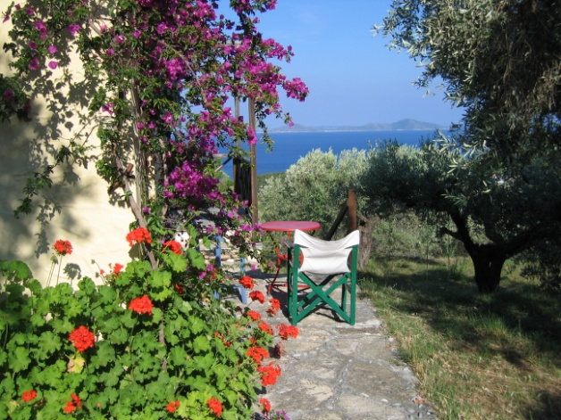 | 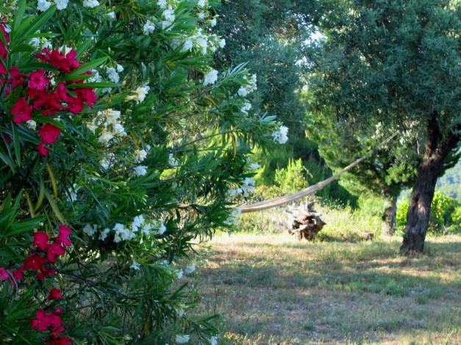
The course centre
The daily program
Every day we do the whole workout but focus on certain exercises.
Day 1: Morning 9:30-13:30: Root Chakra intro and gym, we focus on grounding. After this we learn more about the Root Chakra and do different tasks.
Afternoon 18-20: We visit two small chapels situated in dense pinewoods at the edge of steep cliffs with a fantastic view over the sea. Here we sit for ½ an hour and make a grounding meditation under my instruction and in general we pay attention to all the different scents surrounding us.
The walk takes about 45 minutes each way through scented pinewoods along beautiful footpaths and earth roads.
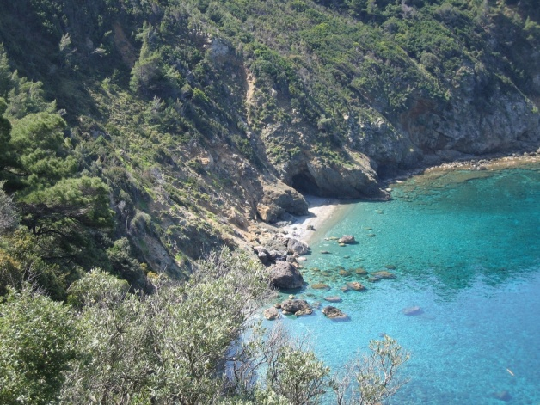 | 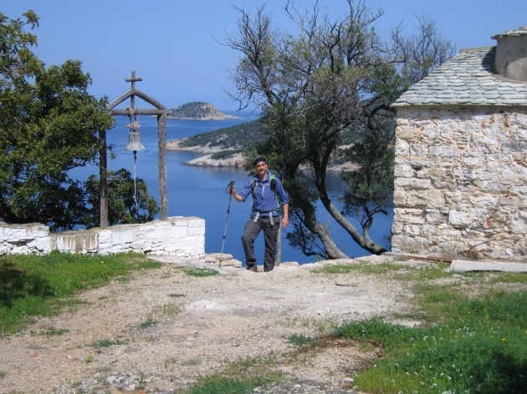
Ag. Anargiri, our destination the first day
Day 2:
Morning 9:30-14:00: Sacral Chakra intro and gym, we focus on flow. We learn more about the Sacral Chakra and do different tasks. We visit a nearby beach and perform a flow-exercise in the sea under my instruction.
Afternoon 20:00-21:30: We visit a taverna to stimulate our sense of taste
Day 3:
Morning 9:30-14:00: Solar plexus Chakra intro and gym, we focus on strength. We learn more about the Solar plexus Chakra. You exercise your vision - to perceive your surroundings in a new way. We make different tasks and discuss our personal power. I guide you through a solar plexus meditation.
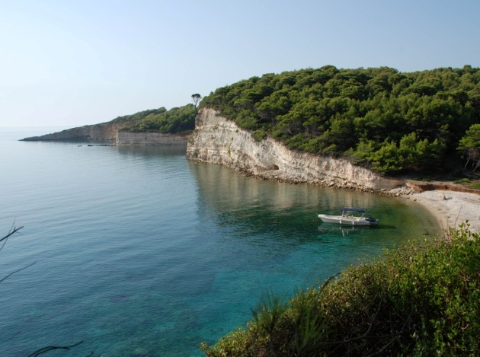 | 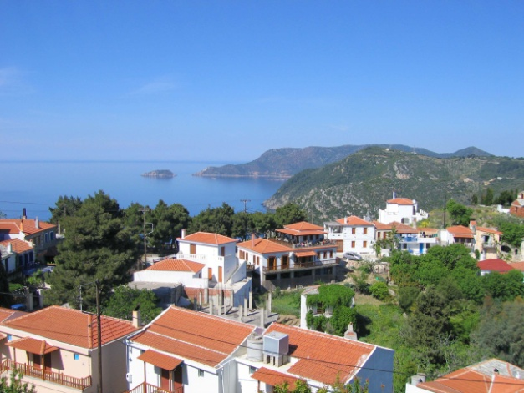
Beach and the Old Village, beauty everywhere,
Day 4:
Morning 9:30-13:30: Heart Chakra intro and gym, we focus on happy dancing. We learn more about the Heart Chakra and do different tasks.
Afternoon 18-20: We take the bus to the Old Village and then we walk to a nearby small chapel along a beautiful footpath with view of the sea on both sides. Here we speak more about the heart chakra and I guide you through a heart chakra meditation. After that we return to the Old Village.
We visit my gallery and there the program of the day finishes. There are many tavernas and cafés in the village so you can stay if you like.
There is a bus between The Old Village and Patitiri/Votsi every hour.
Day 5:
Morning 9:30-14:00: Throat Chakra intro and gym, we focus on stretching and listening to our body. We learn more about the Throat Chakra and speak about our wishes and create our own affirmations. We listen to music, we discuss about our inner ear and I guide you through a throat chakra meditation.
Day 6:
Morning 9:30-14:00: Brow Chakra intro and gym, we focus on relaxation and visualization. We learn more about the Brow Chakra and we turn our affirmation from yesterday into a visualization. We speak about intuition and inner vision. We make a final brow chakra meditation and we finish hopefully happy and full of new energy .
More about BodyMind Empowerment gym
- BodyMind Empowerment gymnastics is based on different kind of western and eastern exercise principles such as yoga, Pilates, Swedish gymnastics and rhythmic movement to music. The purpose of the gymnastics is to increase the blood circulation, to soften your joints, strengthen your muscles and to enjoy moving to the rhythm of music.
- The exercises are specially chosen to fit with each chakra of the body enhancing and balancing their energy. We start for example with many grounding exercises to balance the root chakra and then we continue with other kind of exercise for each chakra. The existence of these chakras is scientifically proven at the same level as other physiological feedback systems in our body such as hormones.
- The relaxation teaches you how to feel the difference between a tense and a relaxed muscle and how you can influence with your thoughts muscle tonus (tension).
How to reach Alonnisos
You can check on the internet for package holidays to Alonissos. I suggest you
choose a hotel in Votsi, Rousoum or Patitiri to be close to where the seminar is held.
If you prefer to arrange the trip yourself you have to look for flights to the island of Skiathos. From Skiathos it takes 1½-3 hours to Alonissos with a hydrofoil or ferry.
If you prefer to fly to Thessaloniki, Athen or Volos it takes between 3 to 6 hours to reach Alonnisos.
Via Skiathos, Volos and Thessaloniki: Ferry boats or Flying Dolphin or CAT, which are hydrofoils to Alonnisos. See Hellenic Seaways www.hsw.gr or www.openseas.gr for reservation, time schedule and prices.
Via Athens: Flights to Athens and then a bus from the center of Athens to Agios Konstantinos, Volos, Kimi or Mantoudi and from there ferry boat or Flying CAT hydrofoil to Alonnisos. The bus services usually connect with the Flying CAT or ferries. See Hellenic Seaways www.hsw.gr or www.openseas.gr for reservation, time schedule and prices.
UNFORTUNATELY THE SUMMER TIMETABLES ARE OUT LATE SO IT’S DIFFICULT TO BOOK EARLY
Accommodation
Either you prefer a package solution or find accommodation on your own I recommend accommodation in Votsi, Rousoum or Patitiri which is close to the course centre.
Oniro: Big studios including kitchen, toilet and bath or double rooms including refrigerator, water-boiler, toilet and bath. Breakfast service. Great view over the harbour of Votsi and the sea.
More information and booking: http://www.pension-oniro.gr .
Hippocampus: Big studios including kitchen, toilet and bath. Breakfast service. Great view over the harbour of Votsi and the sea.
More information and booking http://www.hippocampusstudios.gr.
For more accommodation see www.alonissos.gr → accommodation
Terms and Conditions
The booking is binding and if you cancel more than 40 days before the start of the course only 50% of the deposit will be returned.
If you cancel less than 40 days prior to the course your payment will be returned only in case of documented illness and minus 50% of the deposit.
About Alonnisos
Alonnisos is a beautiful, green island situated in the northwest of the Aegean Sea, about 40 kilometres from Pelion on the Greek mainland. It belongs to the Northern Sporadic group of islands, which from a geological standpoint are contiguous with the mainland, despite the intervening submerged area. Alonnisos is a roughly oblong island, about 20 km long and between 3 km and 4 km wide. The island has a magnificent and varied natural history which has made a deep impression on generations of visitors.
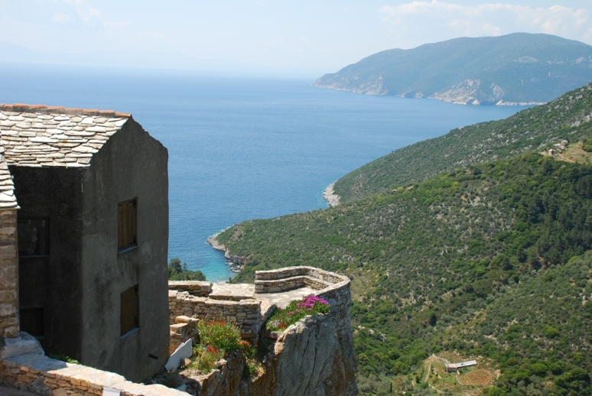 | 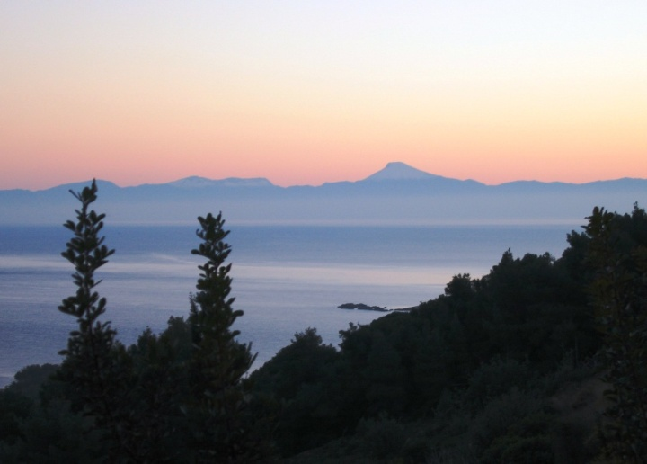
Even as the boat approaches the island, your first impressions are of a landscape rich in contrasts. The western promontory rises precipitously from the sea in rugged cliff formations to a height of 300 metres but soon rolling, green hills emerge from behind the promontory, and a small village appears at their peak. This village, Palia Alonnisos (Old Alonnisos), is the former main settlement of the island.
After another 15 minutes travel along the beautiful pine-clad southeast coast you arrive at the main harbour of the island, Patitiri. The harbour is situated in a small bay with clear turquoise waters, surrounded by steep, ochre-yellow cliffs. The area behind the harbour is densely developed and the built-up area continues into the next bay, Rousoum, and on into the neighbouring fishing village of Votsi.
Apart from these settlements (Palia Alonnisos, Patitiri and Votsi) there are two more villages, both further up the southeast coast. The first is Steni Vala (by road, 10 km from Patitiri), a charming little fishing village and home port for many sailors, as it is the last place to take on provisions before visiting the many uninhabited islands in the area. A little further up the coast is the last small built-up area Kalamakia, which consists of a few houses and a small harbour.
Alonnisos is studded with beaches where you can swim in the crystal clear waters. Each of the beaches is more picturesque than the last, and they are all very different in character.
The colourful landscape, the dramatic cliffs and the wide variety of vegetation on the island make it a magnet for nature-lovers; just to take in the fantastic views, or to smell the aromatic herbs that grow all over the island, are wonderful experiences in themselves.
There are many possibilities for hiking in Alonnisos, as many of the old donkey paths are kept open, and most of the areas of the island are easy to reach, even with peaks of up to 475 metres.
If you want to read more about Alonnisos see The Alonnisos Guide and Alonnisos on Foot.

